Analysis for MathJax

What is MathJax?

MathJax is a tool for programmers to make your code displayed clearly and accurately in the language of mathematics. It is commonly used in educational and academic applications and websites. For example, the web work system of mathematic department of Wilfrid Laurier university is based on MathJax. All the questions and equations are written in MathJax. As it is stated in the official website of MathJax: “The core of the MathJax project is the development of its state-of-the-art, open source, JavaScript platform for display of mathematics.” (MathJax.org, n.d.) Therefore it is reasonable to use MathJax as one of the tools to develop UPOD for the physics department of Wilfrid Laurier University.

The Advantages of MathJax

* high-quality display of mathematics notation in all browsers
* no special browser setup required
* support for LaTeX, MathML and other equation markup directly in the HTML source.
* an extensible, modular design with a rich API for easy integration into web applications.
* support for accessibility, copy and paste and other rich functionality

interoperability with other applications and math-aware search.

(MathJax.org, n.d.)

Competitor of MathJax: KaTeX

KaTex is a new programming tool which is developed by Ben Alpert and Emily Eisenberg at Khan Academy. In general, KaTeX is the identical tool compare to MathJax. It can display any math equation in website. Furthermore, it is even better than MathJax. “You can see immediately that KaTeX produces math much faster than MathJax. This is because KaTex "renders its math synchronously and doesn't need to reflow the page", according to their short blurb on Github.

There is obviously much less time required for processing. KaTeX doesn't suffer from the page reflow jumps that MathJax has after each equation is created. (To be fair, there are ways around those instabilities in MathJax.)” (Bourne, n.d.) However KaTeX has its problems. When users and visitors open the website in IE browser, KaTeX will have problems while the equations are being displayed. The mathematical language will be illustrated unclearly and accurately. KaTex is not fully developed yet. “KaTeX doesn't do everything yet (it chokes on anything starting with \begin, \align or \choose, and many symbols don't work yet).” (Bourne, n.d.) For more imformation about KaTex, please visit <https://github.com/Khan/KaTeX>

Why MathJax?

As the information has been mentioned before, MathJax is very reliable and widely used. First It can be opened in almost all the popular browsers in current time. Second it has been tested by time. The project of MathJax started in 2009 and it collected huge amount users in 7 years. Third, its competitor is not mature enough. Although KaTeX can process faster than MathJax, KaTeX still has some functional problem in display math equations. Forth the client had experience of using MathJax. The mathematics department of Wilfrid Laurier University is using MathJax in the web work system. In conclusion MathJax is the best option in current stage.

How to write MathJax in LaTeX?

LaTeX is a way of writing MathJax. It has its own formatting and documentation.

$…$ inline formulas

\(…\) inline formulas

$$…$$ idependent display

{…} define the scope of instruction

% Comments

\\ change line

_ subscripted

^ superscripted

e.g. A_{u,v}^k     

\sum_{i=1}^n i = \frac{n(n+1)}2   may render



\displaystyle\sum_{i=1}^n i = \frac{n(n+1)}2   renders



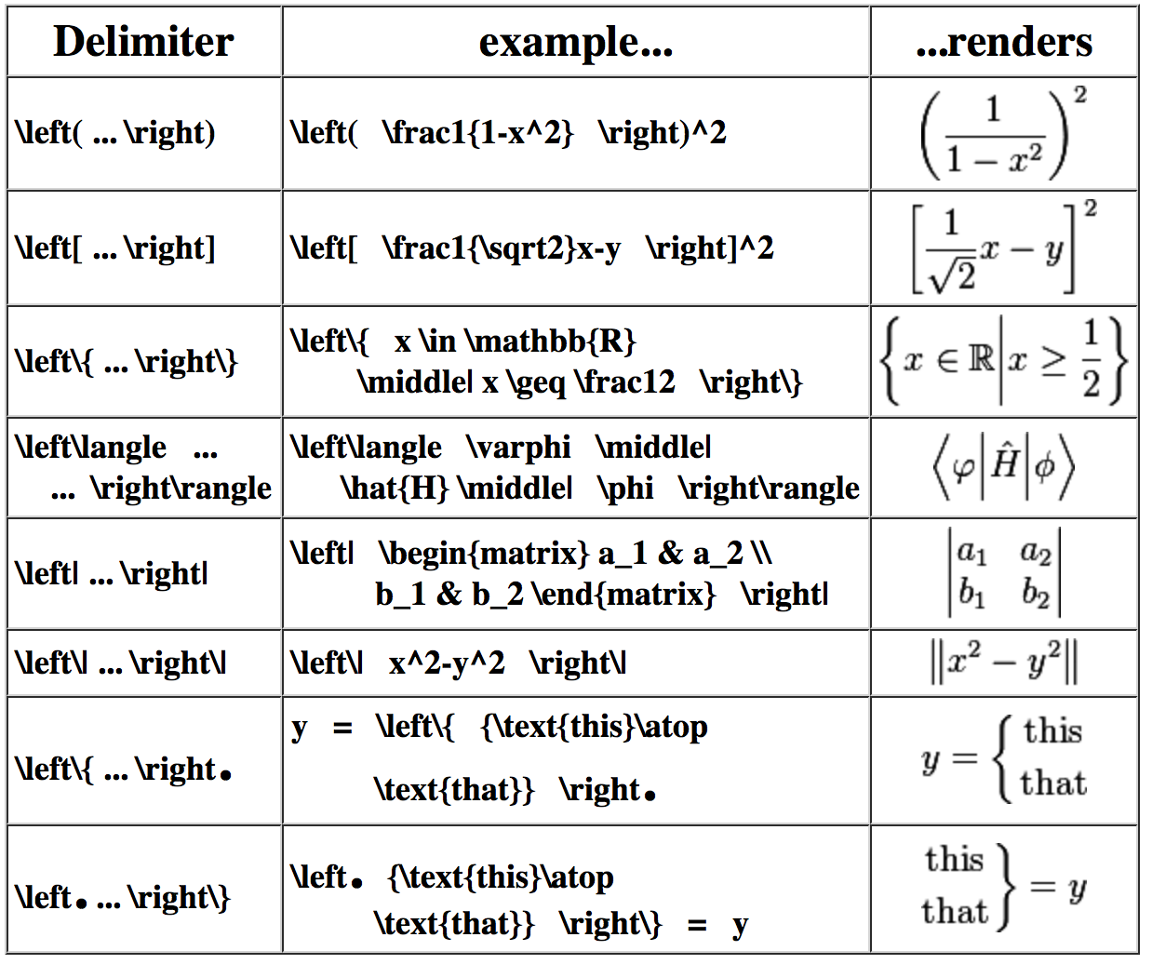**Delimiters**



**SIZE**

\tiny\sqrt{a^2+b^2}

\small\sqrt{a^2+b^2}

\normalsize\sqrt{a^2+b^2}

\large\sqrt{a^2+b^2}

\Large\sqrt{a^2+b^2}

\LARGE\sqrt{a^2+b^2}

\huge\sqrt{a^2+b^2}

\Huge\sqrt{a^2+b^2}

**Function**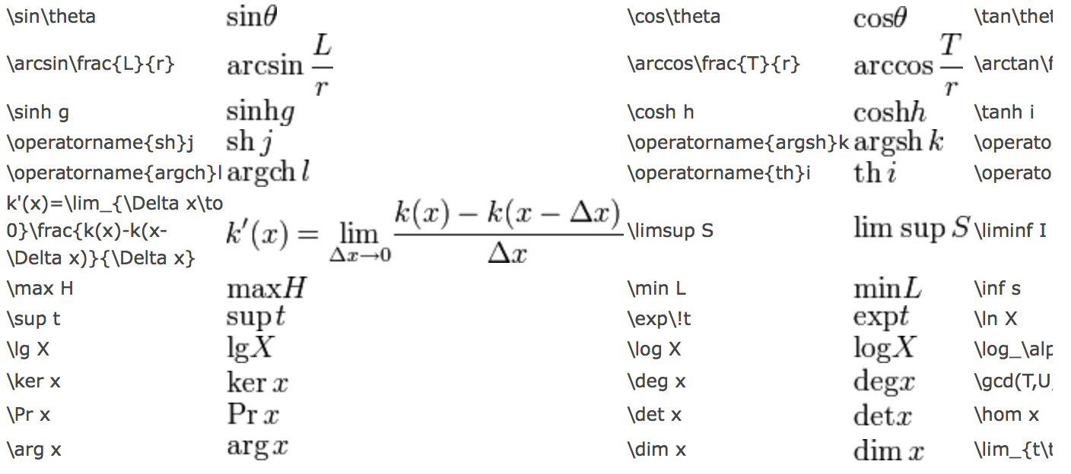

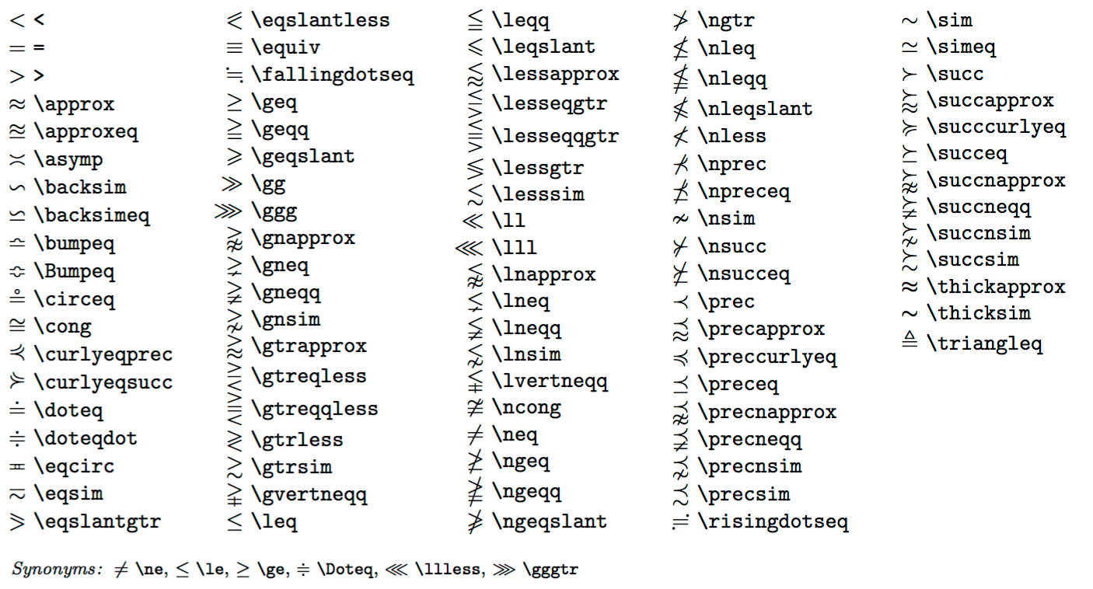

**Relation symbols**

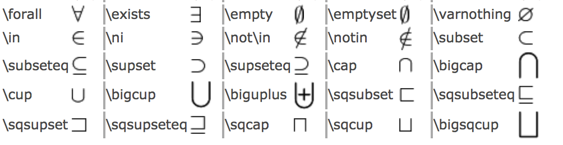**Greek letters**

